

The 2010 Bolingbroke Southern Jam Sponsorship Form
Benefiting “Pine Pointe at Hospice of Central Georgia”
(In honor of Gail Davis)
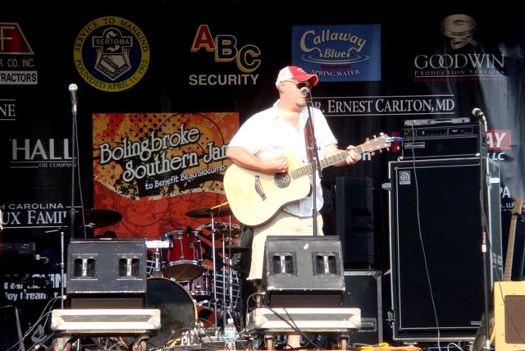
EVENT SPONSOR
($5,000)
VENUE SPONSOR
($2,500)
GOLD SPONSOR
($1,000)
SILVER SPONSOR
($500)
BRONZE SPONSOR
($250)
FRIEND
($100)

Name: ____________________ Event Sponsor _____
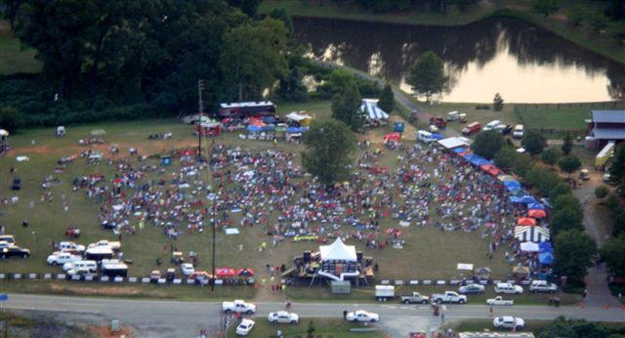
Company: _____________________ Venue Sponsor _____
Address: ____________________ Gold Sponsor _____
____________________ Silver Sponsor _____
Phone: ____________________ Bronze Sponsor _____
Email: ____________________ Friend _____

Make donation payable to:
Hospice of Central Georgia (non-profit)
For: The Bolingbroke Southern Jam Benefit
858 High Street
Macon, GA 31204

